### **BUSINESS PROBLEM ANALYSIS**

#### Key Questions:

1. **How does the training budget allocation affect customer retention and projected revenue?**
2. **What is the impact of customer retention on ROI?**
3. **How can we optimize these metrics for better business performance?**

### **Approach**

#### 1. Correlation Analysis:

* Showcases relationships between:
  + **Training Budget Allocation ($)** and **Customer Retention (%).**
  + **Customer Retention (%), ROI (%), and Projected Revenue ($).**

#### 2. Regression Analysis:

* Assesses:
  + The influence of **Training Budget Allocation ($)** on **Customer Retention (%).**
  + The impact of **Customer Retention (%)** on **ROI,** **Projected Revenue ($).**

#### 3. Insights and Recommendations:

### **Results**

#### 

##### **CUSTOMER RETENTION AND TRAINING BUDGET ALLOCATION RELATIONSHIP**

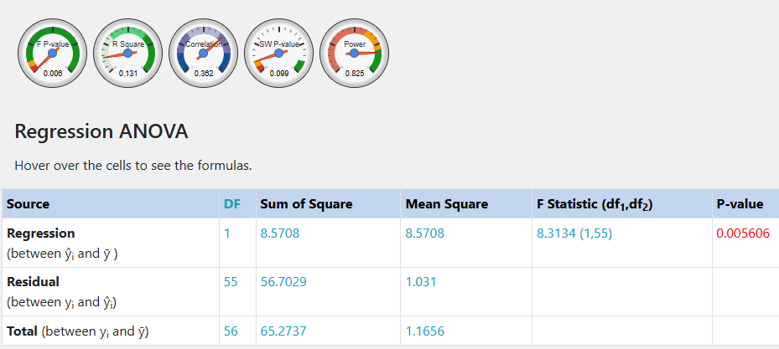

Regression line equation Ŷ = 19.8125 + 0.0001392X

**Hypothesis:**

Ho **:** Training Budget Allocation has no significant impact on Customer Retention

H1 **:** Training Budget Allocation has a significant impact on Customer Retention

**Decision:**

Since the p-value (0.005606) is less than the value of ɑ (0.05), we reject Ho and state that Training Budget Allocation has no significant impact on customer Retention.

R-Squared (R2) equals **0.1313.** This means that 13.1% of the variability of CUSTOMER RETENTION is explained by TRAINING BUDGET ALLOCATION.

Correlation (R) equals **0.3624**. This means that there is a **weak direct relationship** between TRAINING BUDGET ALLOCATION and CUSTOMER RETENTION.

The Standard deviation of the residuals (Sres) equals **1.0154**.

The slope: b₁=**0.0001392** CI[0.00004244, 0.0002359] means that when you increase TRAINING BUDGET ALLOCATION by 1, the value of CUSTOMER RETENTION increases by 0.0001392.

The y-intercept: b₀=**19.8125** CI[19.4726, 20.1524] means that when TRAINING BUDGET ALLOCATION equals 0, the prediction of CUSTOMER RETENTION's value is 19.8125.  
The x-intercept equals -142354.4162.

##### **Goodness of fit**

Overall regression: right-tailed, F(1,55) = **8.3134**, p-value = **0.005606**. Since p-value < α (0.05), we reject H0.

The linear regression model, **Y = b0+ b1X + ε**, provides a better fit than the model without the independent variable resulting in **Y = b0 + ε**.

The slope (b₁): two-tailed, T(55)=**2.8833**, p-value = **0.005606**. For one predictor it is the same as the p-value for the overall model.

The y-intercept (b₀): two-tailed, T(55) = **116.8104**, p-value = **0**. Hence, b₀ is significantly different from zero.

##### **Residual normality**

The linear regression model assumes normality for residual errors. The Shapiro-Wilk p-value equals **0.09911**. It is assumed that the data is normally distributed,

##### **Outliers**

The data does not contain any outliers.

##### **RETURN ON INVESTMENT AND CUSTOMER RETENTION RELATIONSHIP**

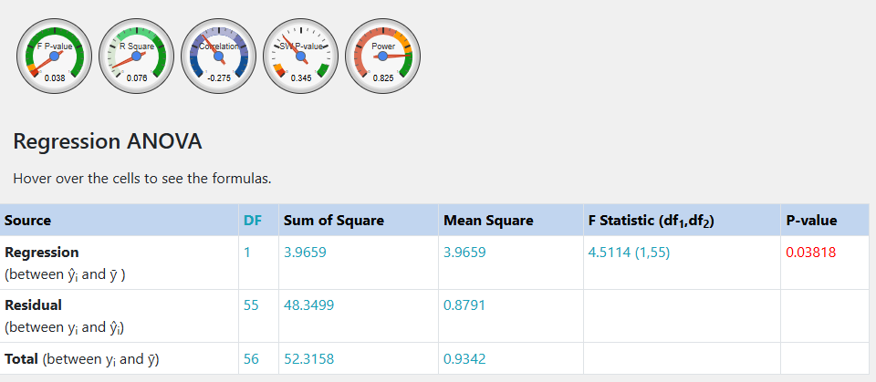

Regression line equation Ŷ = 9.2729 - 0.2465X

**Hypothesis:**

Ho **:** Customer Retention has no relationship with Return on Investment

H1 **:** Customer Retention has a relationship with Return on Investment

**Decision:**

Since the p-value (0.03818) is less than ɑ (0.05), we reject Ho and state that Customer Retention has a relationship with Return on Investment.

R-Squared (R2) equals **0.07581.** This means that 7.6% of the variability of RETURN ON INVESTMENT is explained by CUSTOMER RETENTION .

Correlation (R) equals **-0.2753**. This means that there is a **weak inverse relationship** between CUSTOMER RETENTION and RETURN ON INVESTMENT.

The Standard deviation of the residuals (Sres) equals **0.9376**.

The slope: b₁=**-0.2465** CI[-0.4791, -0.01392] means that when you increase CUSTOMER RETENTION by 1, the value of RETURN ON INVESTMENT decreases by 0.2465.

The y-intercept: b₀=**9.2729** CI[4.5892, 13.9566] means that when CUSTOMER RETENTION equals 0, the prediction of RETURN ON INVESTMENT's value is 9.2729.

The x-intercept equals 37.6193.

##### **Goodness of fit**

Overall regression: right-tailed, F(1,55) = **4.5114**, p-value = **0.03818**. Since p-value < α (0.05), we reject H0.

The linear regression model, **Y = b0+ b1X + ε**, provides a better fit than the model without the independent variable resulting in **Y = b0 + ε**.

The slope (b₁): two-tailed, T(55)=**-2.124**, p-value = **0.03818**. For one predictor it is the same as the p-value for the overall model.

The y-intercept (b₀): two-tailed, T(55) = **3.9676**, p-value = **0.000212**. Hence, b₀ is significantly different from zero.

##### **Residual normality**

The linear regression model assumes normality for residual errors. The Shapiro-Wilk p-value equals **0.3453**. It is assumed that the data is normally distributed,

##### **Outliers**

The data does not contain any outliers.

##### **CUSTOMER RETENTION AND PROJECTED REVENUE RELATIONSHIP**

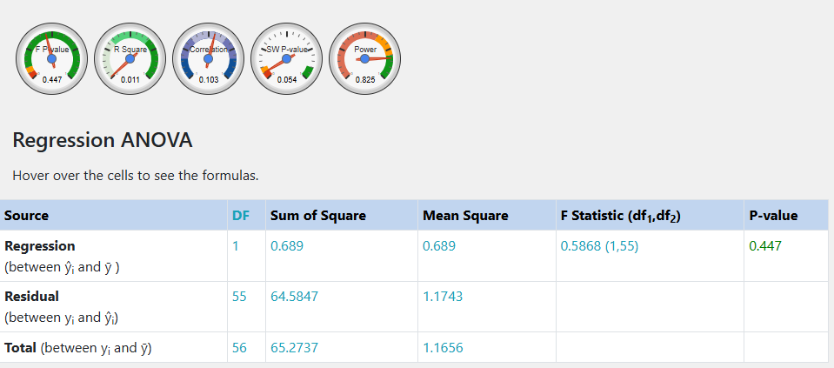

Ŷ = 19.4894 + 0.0001415X

**Hypothesis:**

Ho **:** Projected Revenue has no significant impact on Customer Retention

H1 **:** Projected Revenue has a significant impact on Customer Retention.

**Decision:**

Since the p-value (0.447) is greater than ɑ (0.05), **we fail to reject** the null hypothesis (Ho) and therefore state that Projected Revenue has no significant impact on Customer Retention.

R-Squared (R2) equals **0.01056.** This means that 1.1% of the variability of CUSTOMER RETENTION is explained by PROJECTED REVENUE.

Correlation (R) equals **0.1027**. This means that there is a **very weak direct relationship** between PROJECTED REVENUE and CUSTOMER RETENTION.

The Standard deviation of the residuals (Sres) equals **1.0836**.

The slope: b₁=**0.0001415** CI[-0.0002287, 0.0005118] means that when you increase PROJECTED REVENUE by 1,

the value of CUSTOMER RETENTION increases by 0.0001415.

The y-intercept: b₀=**19.4894** CI[17.8393, 21.1396] means that when PROJECTED REVENUE equals 0, the prediction of CUSTOMER RETENTION's value is 19.4894.

The x-intercept equals -137710.0848.

##### **Goodness of fit**

Overall regression: right-tailed, F(1,55) = **0.5868**, p-value = **0.447**. Since p-value ≥ α (0.05), we accept H0.

The linear regression model, **Y = b0+ b1X + ε**, doesn't provide a better fit than the model without the independent variable resulting in **Y = b0 + ε**.

The slope (b₁): two-tailed, T(55)=**0.766**, p-value = **0.447**. For one predictor it is the same as the p-value for the overall model.

The y-intercept (b₀): two-tailed, T(55) = **23.6691**, p-value = **0**. Hence, b₀ is significantly different from zero.

##### **Residual normality**

The linear regression model assumes normality for residual errors. The Shapiro-Wilk p-value equals **0.05383**. It is assumed that the data is normally distributed,

##### **Outliers**

The data does not contain any outliers.

### **Insights**

#### Key Question 1: How does the training budget allocation affect customer retention and projected revenue?

1. **Training Budget Allocation and Customer Retention**:
   * **Insight**:
     + The regression analysis shows that **13.1% of customer retention variability** is explained by training budget allocation.
     + **Correlation (R = 0.3624)** indicates a weak positive relationship, suggesting that higher budget allocation has a limited but direct effect on retention.
   * **Recommendations**:
     + Gradually increase the budget allocation for processes with consistent or above-average retention rates to maximize returns.
     + Focus on improving budget efficiency by identifying high-impact training modules.
2. **Training Budget Allocation and Projected Revenue**:
   * **Insight**:
     + The relationship between projected revenue and budget allocation is **statistically insignificant (p-value = 0.447)**, with a very weak correlation (R = 0.1027).
   * **Recommendations**:
     + Reevaluate current revenue projection methods; training alone may not directly influence revenue growth.
     + Explore additional variables like customer satisfaction or market penetration to determine revenue drivers.

#### Key Question 2: What is the impact of customer retention on ROI?

* **Insight**:
  + Regression analysis indicates a **weak negative correlation (R = -0.2753)** between customer retention and ROI.
  + **7.6% of ROI variability** is explained by retention, suggesting that higher retention might lead to increased costs, slightly reducing ROI.
* **Recommendations**:
  + Analyze the cost-benefit ratio of retention strategies to optimize ROI.
  + Prioritize retention efforts for high-value customer segments or processes with a high lifetime value.

#### Key Question 3: How can we optimize these metrics for better business performance?

1. **Improve Customer Retention**:
   * **Focus Areas**:
     + Use feedback loops to improve satisfaction scores (currently low, averaging 2.5/10).
     + Enhance training content to address key customer pain points.
   * **Tactics**:
     + Introduce retention bonuses for key accounts.
     + Implement targeted retention campaigns for underperforming segments.
2. **Maximize ROI**:
   * **Focus Areas**:
     + Monitor resource allocation to minimize diminishing returns from excessive retention spending.
   * **Tactics**:
     + Leverage automation to streamline customer support and reduce operational costs.
     + Align retention strategies with processes that yield higher ROI.
3. **Optimize Training Budgets**:
   * **Focus Areas**:
     + Redirect funds toward processes with a stronger link between budget and retention (e.g., **AI Tools Training** and **Ethical AI Development**).
   * **Tactics**:
     + Perform cost-benefit analyses on budget allocation.
     + Adopt data-driven budget allocation strategies, emphasizing underfunded processes with high potential

### **Executive Summary**

1. **Insights**:
   * Training budget allocation has a **weak positive effect** on customer retention but minimal influence on projected revenue.
   * Higher customer retention does not always lead to higher ROI due to associated costs.
   * Projected revenue is not significantly influenced by retention or training budgets in isolation.
2. **Key Recommendations**:
   * **Reallocate Training Budgets**:
     + Invest in targeted areas with higher retention impacts.
   * **Optimize Retention Efforts**:
     + Focus on satisfaction improvement to complement retention strategies.
   * **Drive ROI Growth**:
     + Minimize inefficiencies in high-cost retention programs while prioritizing high-value customer segments.
3. **Strategic Recommendations:**
   * + 1. **Budget Optimization**:
   * Restructure training budget allocation since current impact on retention is minimal
   * Identify and invest in high-impact training programs
   * Implement pilot programs to test different budget allocation strategies
   * Consider segmenting budget based on process performance
     1. **Retention Enhancement**:
   * Investigate non-budget factors affecting retention
   * Develop comprehensive retention strategy beyond training
   * Focus on quality metrics alongside quantity
   * Implement regular feedback mechanisms
     1. **ROI Improvement**:
   * Balance retention efforts with cost efficiency
   * Develop targeted programs for different customer segments
   * Optimize resource allocation based on ROI metrics
   * Implement ROI tracking at process level
4. **Revenue Growth**:
   1. Look beyond retention for revenue drivers
   2. Develop multi-faceted approach to revenue growth
   3. Focus on customer value maximization
   4. Implement revenue diversification strategies
5. **Next Steps**:
   * Develop detailed action plans for budget reallocation, satisfaction improvement, and ROI tracking.
   * Incorporate satisfaction data and customer segmentation into future analyses for enhanced insights.

### **Action Plans**

1. **Short-term (0-3 months)**:
   * Audit current training programs
   * Implement enhanced tracking metrics
   * Develop pilot programs for budget optimization
   * Start customer feedback collection
2. **Medium-term (3-6 months)**:
   * Roll out optimized training programs
   * Implement new retention strategies
   * Develop process-specific ROI targets
   * Begin segmented budget allocation
3. **Long-term (6-12 months)**:
   * Full implementation of optimized programs
   * Regular review and adjustment of strategies
   * Development of predictive models
   * Implementation of automated tracking systems

### **Performance Monitoring**

1. Establish KPI dashboards
2. Regular review of metrics
3. Quarterly strategy adjustments
4. Annual comprehensive review